**MyClickerr APIs**

1. Delete Account API

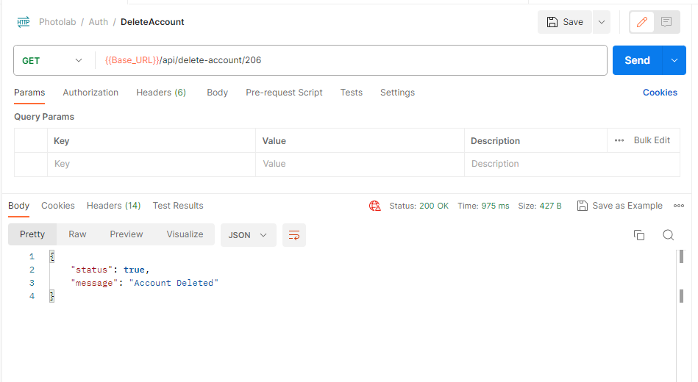

1. Reschedule Booking

